1.Internal CSS

comment in css

**/* */**

Shortcut in vs code **ctrl+/**

1.1. HTML COLOR LINK

https://htmlcolorcodes.com/

https://htmlcolorcodes.com/color-names/

https://colorhunt.co/

https://colorhunt.co/palettes/popular

<!DOCTYPE html>

<html lang="en">

<head>

    <meta charset="UTF-8">

    <meta name="viewport" content="width=device-width, initial-scale=1.0">

    <title>Document</title>

    <style>

        body{

            text-align: center;

            padding: 10px;

        }

        h1{

            color: #ab1d1d;

*/*comment in css*/*

*/* comment in shortcut ctrl+/ */*

        }

*/* rgb color */*

        p{

            color:rgb(255, 99, 71);

        }

*/* rgb color with opacity */*

        span{

            color:rgb(255, 20, 147,.5)

        }

    </style>

</head>

<body>

    <h1>Hellow From Utsab</h1>

    <p>This is an example of how CSS of <span>Cascading stylesheet</span></p>

</body>

</html>

1.2 Use Parent and Child for color

(**descendant selector**. The p span part is the descendant selector, where span is a descendant of p)

<!DOCTYPE html>

<html lang="en">

<head>

    <meta charset="UTF-8">

    <meta name="viewport" content="width=device-width, initial-scale=1.0">

    <title>Document</title>

    <style>

        body{

            text-align: center;

            padding: 10px;

        }

        p span{

            color: red;

        }

    </style>

</head>

<body>

    <h1>Hellow From Utsab</h1>

    <p>This is an example of how CSS of <span>Cascading stylesheet</span></p>

    <p>This is an example of how CSS of <span>Cascading stylesheet</span></p>

    <p>This is an example of how CSS of <span>Cascading stylesheet</span></p>

    <span>Utsab</span>

</body>

</html>

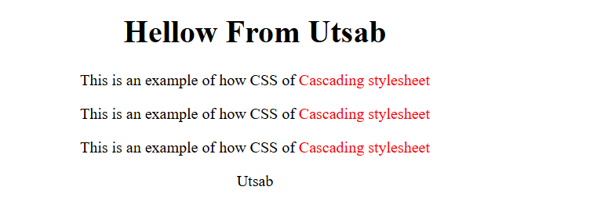

### 1.3

### Class (বিভিন্ন ট্যাগ/ইলিমেন্ট এ একই নাম থাকতে পারে)

* **Definition**: An attribute used to apply the same styles to multiple elements.
* **Usage**: Defined with a dot (.) in CSS (e.g., .example).

**Id (বিভিন্ন ট্যাগ এ ভিন্ন নাম থাকতে হবে , একই নাম রাখা যাবে না। একাধিক ইলিমেন্ট এ একই আইডি থাকা যাবে না।)**

* **Definition**: An attribute used to uniquely identify a single element on a page.
* **Usage**: Defined with a hash (#) in CSS (e.g., #unique).

<!DOCTYPE html>

<html lang="en">

<head>

    <meta charset="UTF-8">

    <meta name="viewport" content="width=device-width, initial-scale=1.0">

    <title>Document</title>

    <style>

        body{

            text-align: center;

            padding: 10px;

        }

        #main-content{

            background-color: #257180;

            padding:10px;

        }

        #main-content-1{

            margin-top:10px;

            background-color: #740938;

            padding:10px;

        }

        .highlight{

            color:#F2E5BF;

            font-weight: bold;

        }

    </style>

</head>

<body>

    <div id="main-content">

        <p class="highlight">This paragraph has a class of "highlight" and is within a div with an ID of "main-content".</p>

        <p class="highlight">This is another paragraph with the same "highlight" class.</p>

    </div>

    <div id="main-content-1">

        <p class="highlight">This paragraph has a class of "highlight" and is within a div with an ID of "main-content".</p>

        <p class="highlight">This is another paragraph with the same "highlight" class.</p>

    </div>

</body>

</html>

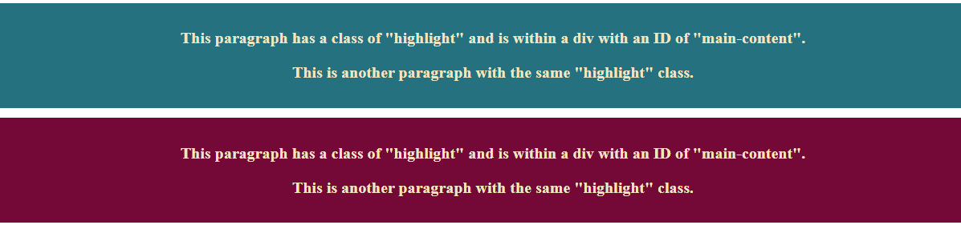

**1.4 same style for multiple div**

<!DOCTYPE html>

<html lang="en">

<head>

    <meta charset="UTF-8">

    <meta name="viewport" content="width=device-width, initial-scale=1.0">

    <title>Document</title>

    <style>

        body{

            text-align: center;

            padding: 10px;

        }

        #main-content,#main-content-1{

            background-color: #257180;

            padding:50px;

        }

    </style>

</head>

<body>

    <div id="main-content">

    </div>

    <div id="main-content-1">

    </div>

</body>

</html>



**2.Font Size px, em ,rem**

**px (Pixels)**

* **Definition**: A fixed, absolute unit of measurement for font size.
* **Behavior**: 1 px equals 1 pixel on the screen, and it does not scale with other settings or screen sizes.

**em (parent এর ‍সাইজ এর নির্ভর করে এটার সাইজ নির্ধারণ হয়, এখানে px-em এর parent হচ্ছে container, container এর ‍সাইজ=20px, তাহলে px-em এর সাইজ হবে=2 em মানে =2*20px=40px)**

* **Definition**: A relative unit based on the font size of the **parent** element.
* **Behavior**: If a parent element has a font size of 16px, 1em is equal to 16px within that context.

**rem (Root em) (root এর ‍সাইজ এর নির্ভর করে এটার সাইজ নির্ধারণ হয়, এখানে px-rem এর root হচ্ছে html, html এর ‍সাইজ=16px, তাহলে px-em এর সাইজ হবে=2 rem মানে =2*16px=32px)**

* **Definition**: A relative unit based on the **root (or <html>) element’s font size**.
* **Behavior**: 1rem is equal to the font size set on the <html> element (often 16px by default in browsers).

<!DOCTYPE html>

<html lang="en">

<head>

    <meta charset="UTF-8">

    <meta name="viewport" content="width=device-width, initial-scale=1.0">

    <title>Document</title>

    <style>

        html{

            font-size: 16px;

        }

        .container{

            font-size:20px;

        }

        .px-example{

            font-size:16px;

        }

        .em-example{

            font-size:2em;

        }

        .rem-example{

            font-size:2rem;

        }

    </style>

</head>

<body>

    <div class="container">

        <p class="px-example">This text is sized in pixels (16px).</p>

        <p class="em-example">This text is sized in em (2em, based on parent size parent is container=20px,this size=2*20).</p>

        <p class="rem-example">This text is sized in rem (2rem, based on root size(root is html=16px , this size=2*16)).</p>

    </div>

</body>

</html>

**3.Margin And Padding**

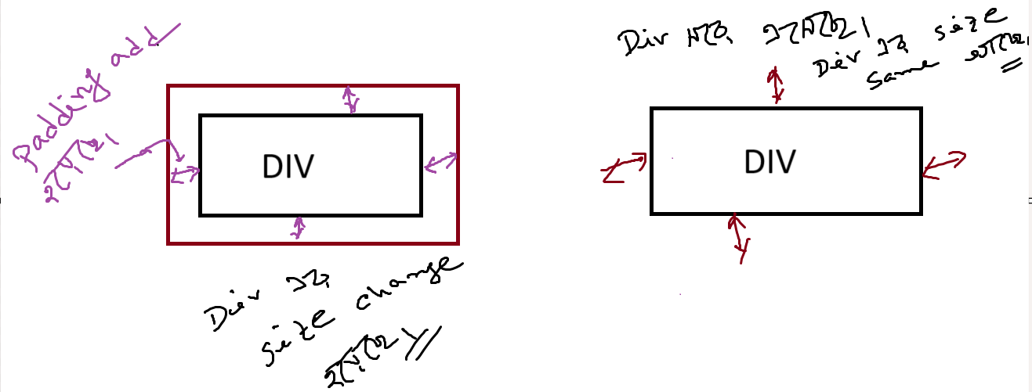

**Padding(মানে space এ্যাড হবে ভিতর থেকে ,এর ফলে space/size বেড়ে যাবে element এর।)**

* **Definition**: Padding is the space that is added **inside** an element's border. It creates distance between the element's content (like text or images) and its border.

**Example:**  <div> with a width of 200px and apply padding: 20px;

total width of the <div>=200+20(top)+20(right)+20(bottom)+20(left)=280px

**Margin(মানে space এ্যাড হবে বাহির থেকে ,এর ফলে size বাড়বে না তবে element সরে যাবে।)**

* **Definition**: Margin is the space that is added **outside** an element's border. It creates distance between the element and other elements on the page.

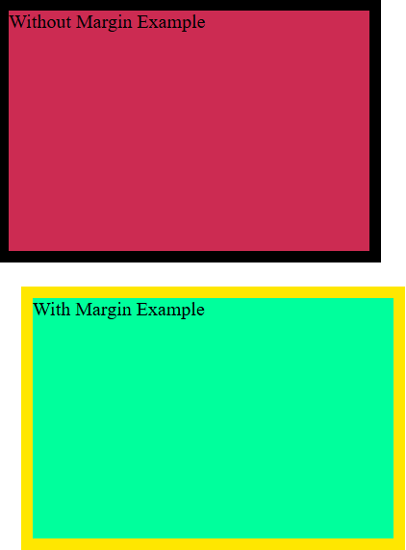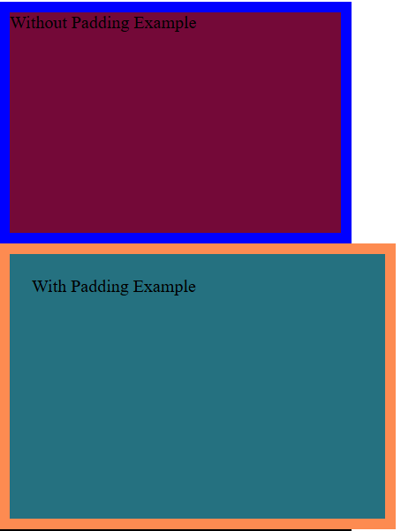**Example:**  <div> with a width of 200px and apply padding: 20px; the space around the element becomes larger, but the size of the <div> itself remains 200px.

<!DOCTYPE html>

<html lang="en">

<head>

    <meta charset="UTF-8">

    <meta name="viewport" content="width=device-width, initial-scale=1.0">

    <title>Document</title>

    <style>

      .without-padding{

        width: 300px;

        height: 200px;

        background-color: #740938;

        border:10px solid blue;

      }

      .with-padding{

        width: 300px;

        height: 200px;

        background-color: #257180;

        border:10px solid #FD8B51;

        padding:20px;

      }

      .without-margin{

        width: 300px;

        height: 200px;

        background-color: #CC2B52;

        border:10px solid black;

      }

      .with-margin{

        width: 300px;

        height: 200px;

        background-color: #00FF9C;

        border:10px solid #FFE700;

        margin:20px;

      }

    </style>

</head>

<body>

    <div class="without-padding">

        Without Padding Example

    </div>

    <div class="with-padding">

        With Padding Example

    </div>

    <div class="without-margin">Without Margin Example</div>

    <div class="with-margin">With Margin Example</div>

</body>

</html>

**4.External CSS**

<!DOCTYPE html>

<html lang="en">

<head>

    <meta charset="UTF-8">

    <meta name="viewport" content="width=device-width, initial-scale=1.0">

    <title>Document</title>

    <link rel="stylesheet" href="assests/css/style.css">

</head>

<body>

   <div class="container">

   </div>

</body>

</html>

Style.css

.container{

    width:500px;

    height: 200px;

    background-color: brown;

}

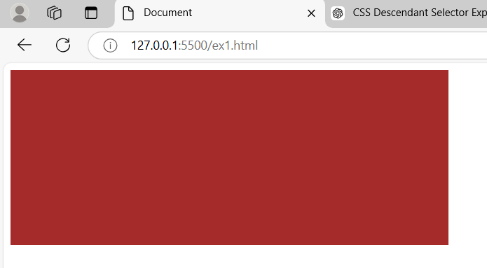

**5.Image Tag**

<img src="image-source.jpg" alt="Description of the image" width="300" height="200">

**6.Anchor Tag**

<a href="URL" target="_blank" title="Description of the link">Link Text</a>

<a href="https://www.example.com" title="Visit Example Website">Visit Example</a>

**7.Font Family**

(এক্ষেত্রে একটা ফন্ট না পেলে আরেকটা খুজবে।)  
(এভাবে ব্যবহার করলে এই Font-Family install থাকতে হবে আমার pc তে।)

<!DOCTYPE html>

<html lang="en">

<head>

    <meta charset="UTF-8">

    <meta name="viewport" content="width=device-width, initial-scale=1.0">

    <title>Document</title>

    <style>

*/* Use Courier New with a fallback to monospace */*

        h1{

            font-family: 'Courier New', Courier, monospace;

        }

*/* Use Arial, fallback to Helvetica, then sans-serif */*

        p{

            font-family: Arial, Helvetica, sans-serif;

        }

    </style>

</head>

<body>

   <div class="container">

        <h1>

            This Is Heading

        </h1>

        <p>This is content of our site</p>

   </div>

</body>

</html>

যদি google font ব্যবহার করি তাহলে এই সমস্যা থাকবে , ফন্ট থাকবে সার্ভার এ ইন্টারনেট থেকে এই ফন্ট আসবে আলাদাভাবে install করতে হবে না।

**https://fonts.google.com/ -> Search specific font (Roboto)-> Click Get Font ->Get Embeded Code ->Copy Code->**

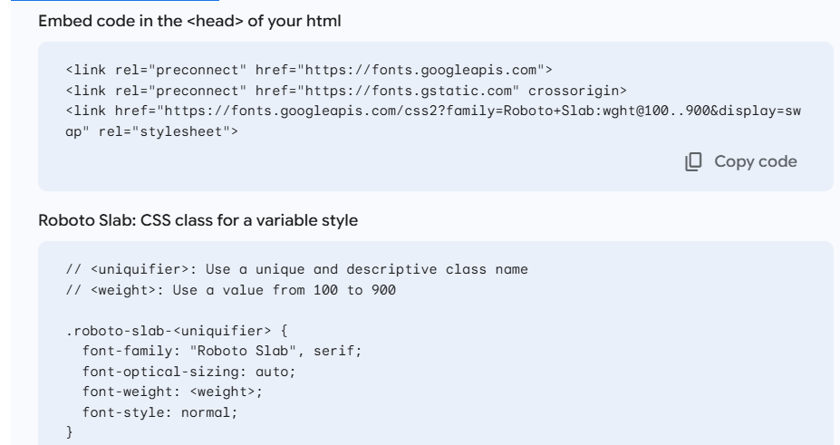

<!DOCTYPE html>

<html lang="en">

<head>

    <meta charset="UTF-8">

    <meta name="viewport" content="width=device-width, initial-scale=1.0">

    <title>Document</title>

    <link rel="preconnect" href="https://fonts.googleapis.com">

    <link rel="preconnect" href="https://fonts.gstatic.com" crossorigin>

    <link href="https://fonts.googleapis.com/css2?family=Roboto+Slab:wght@100..900&display=swap" rel="stylesheet">

    <style>

*/* Use Courier New with a fallback to monospace */*

        h1 {

            font-family: "Roboto Slab", serif;

            font-optical-sizing: auto;

            font-weight: 400;

            font-style: normal;

        }

    </style>

</head>

<body>

    <div class="container">

        <h1>

            This Is Heading

        </h1>

        <p>This is content of our site</p>

    </div>

</body>

</html>

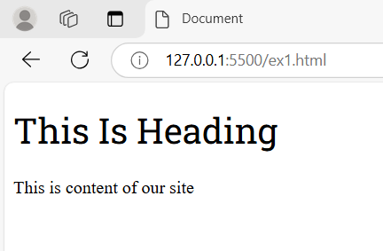

আলাদাভাবে Heading এ কোন ফন্ট দিব , কনটেন্ট এ কোন ফন্ট দিব তার লিস্ট পাওয়া যায়(font-pairings):

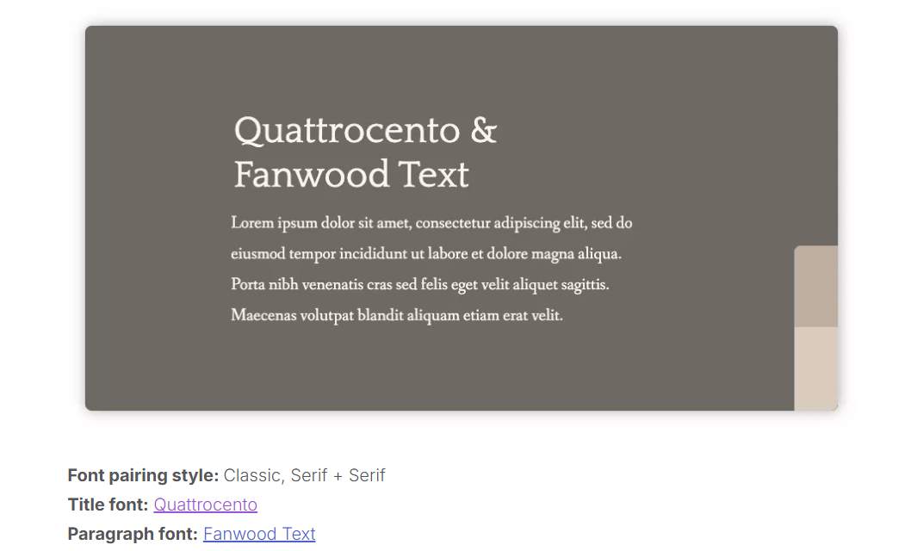

https://www.pagecloud.com/blog/best-google-fonts-pairings

(choose pair from this site -> search in google font(**https://fonts.google.com/**) -> get code)

**8.Position**

**Static:**

When an element has position: static, it is positioned according to the normal flow of the document. This means that the top, right, bottom, and left properties will not have any effect on the element's position.

(static এর ক্ষেত্রে top,right,bottom,left position কাজ করে না। নরমালি টেক্সট যেখানে হওয়ার কথা automatically সেখানে বসবে।)

<head>

    <meta charset="UTF-8">

    <meta name="viewport" content="width=device-width, initial-scale=1.0">

    <title>Document</title>

    <style>

       .container{

        position: static;

        width:300px;

        height: 200px;

        top: 500px;/*not work here if position is static*/

        border: 5px solid red;

       }

    </style>

</head>

<body>

    <div class="container">

       This is container

    </div>

</body>

</html>

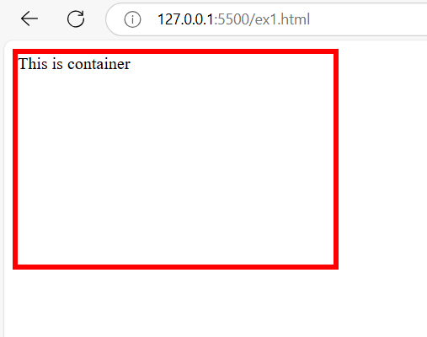

**Relative**:

The element is positioned relative to its original position in the document flow. The top, right, bottom, and left properties will move the element from its normal position.

(এক্ষেত্রে বর্তমানে element যে position এ আছে সে position থেকে top,right,bottom,left এ দেয়া pixel অনুযায়ী সড়বে/position সেট হবে।)

<!DOCTYPE html>

<html lang="en">

<head>

    <meta charset="UTF-8">

    <meta name="viewport" content="width=device-width, initial-scale=1.0">

    <title>Document</title>

    <style>

       .container{

        position: relative;

        width:300px;

        height: 200px;

        top: 300px;

        left:200px;

        border: 5px solid red;

       }

    </style>

</head>

<body>

    <div class="container">

       This is container

    </div>

</body>

</html>

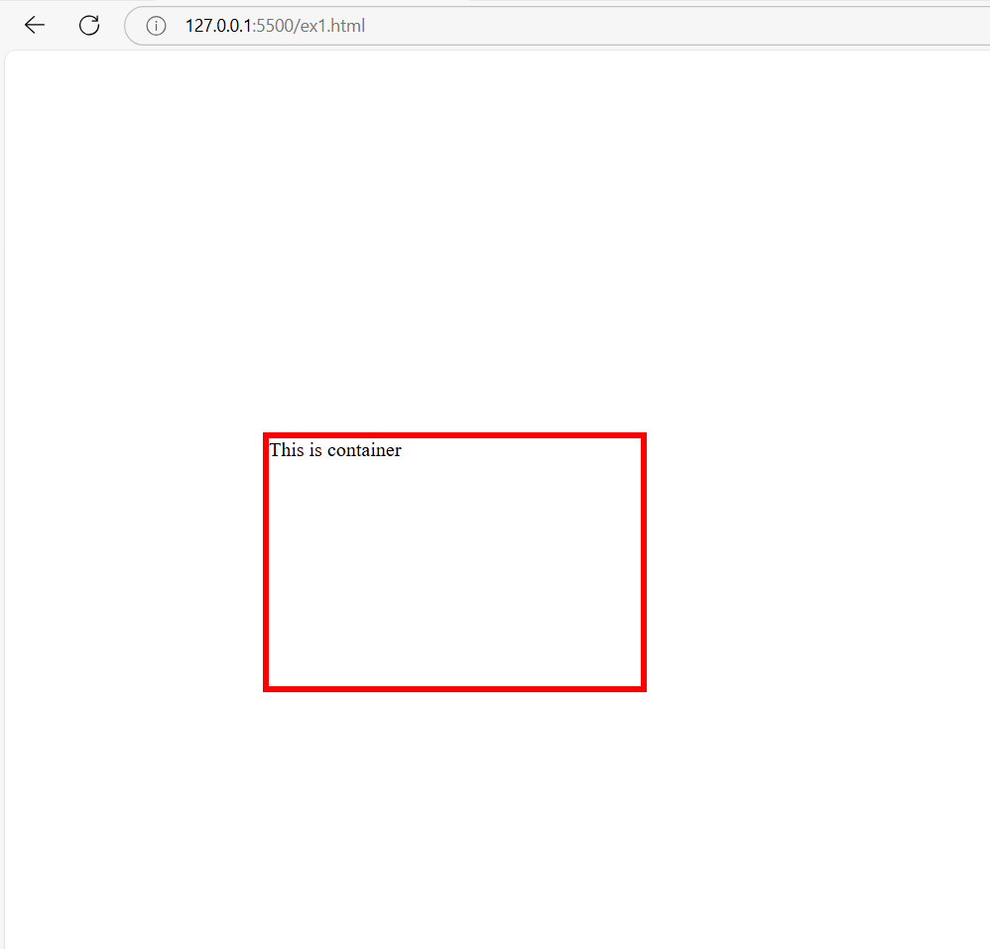

**Absolute:**

An element with position: absolute; is positioned relative to the nearest positioned ancestor (instead of positioned relative to the viewport, like fixed).

(child tag পূর্বের ancestor কে ফলো করে তার পজিশন ঠিক করবে।এক্ষেত্রে বর্তমান পজিশন ফলো না করে বরং তার ancestor কে ফলো কের পজিশন ঠিক করবে।)

<head>

    <meta charset="UTF-8">

    <meta name="viewport" content="width=device-width, initial-scale=1.0">

    <title>Document</title>

    <style>

       .container{

        position: relative;

        width:500px;

        height: 300px;

        top: 0px;

        left:0px;

        border: 5px solid red;

       }

       .inside-container{

        position:absolute;

        width:200px;

        height: 100px;

        bottom: 0px;

        right: 0px;

        border: 5px solid rgb(22, 130, 154);

       }

    </style>

</head>

<body>

    <div class="container">

       <div class="inside-container">

       </div>

    </div>

</body>

</html>

আউটপুটে খেয়াল করলে দেখা যাবে inside-container এর পজিশন হয়েছে container এর উপর ভিত্তি করে।এক্ষেত্রে মনে রাখতে হবে ancestor এর পজিশন রিলেটিভ হতে হবে(static হওয়া যাবে না।)।

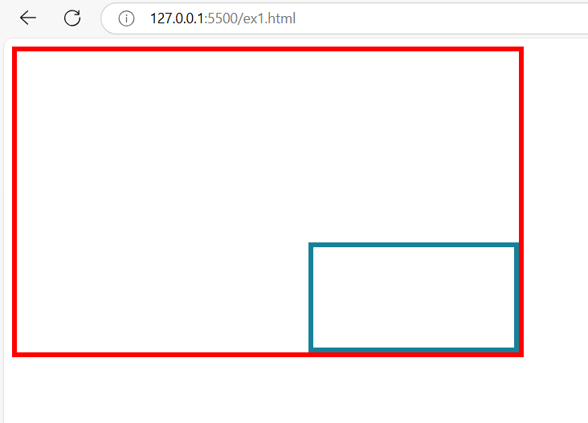

**Fixed:**

An element with position: fixed; is positioned relative to the viewport, which means it always stays in the same place even if the page is scrolled. The top, right, bottom, and left properties are used to position the element.

(এক্ষেত্রে page scroll করলেও page এর পজিশন একই থাকবে।যে পজিশন এ দেয়া সেখানে ফিক্সড থাকবে।)

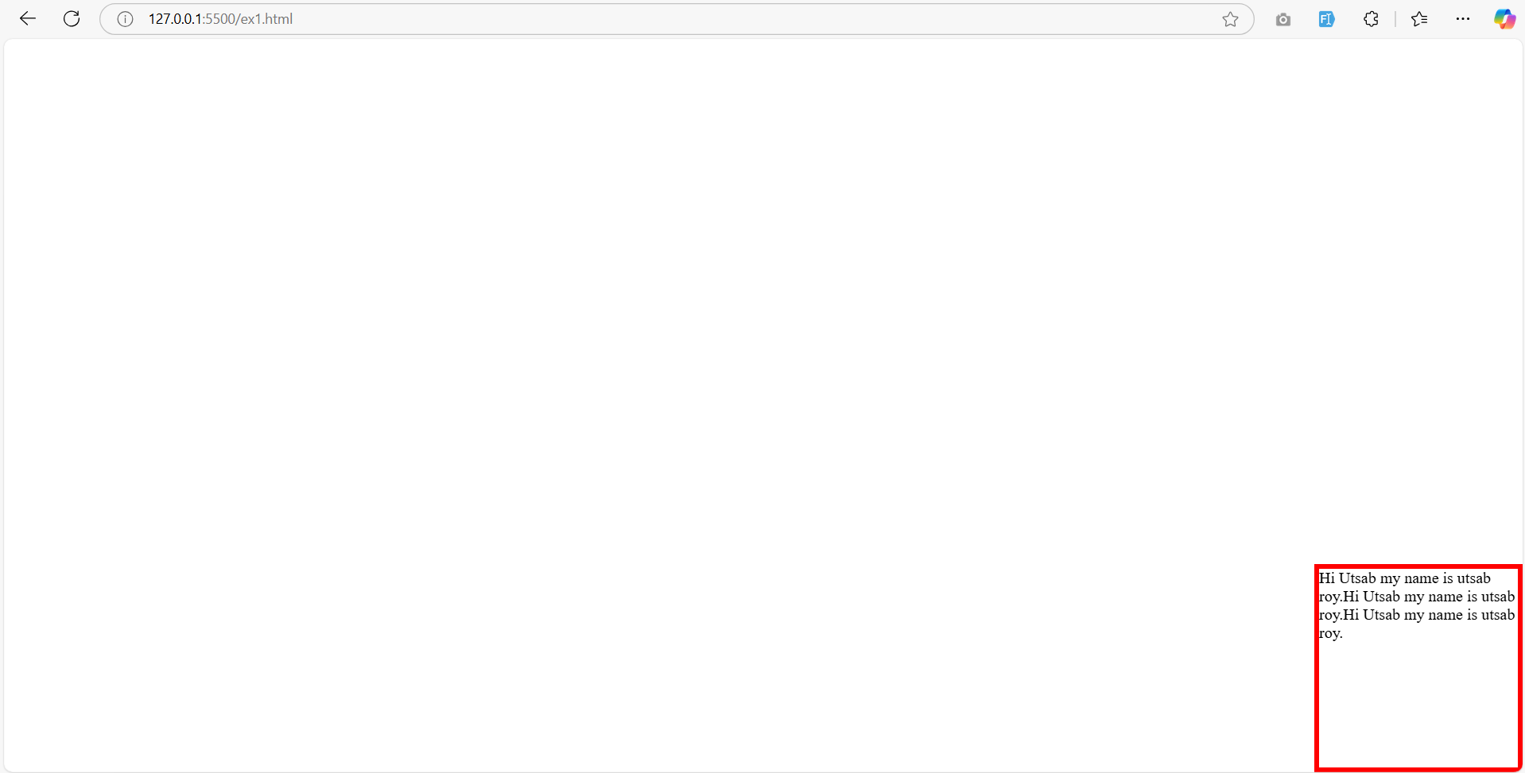

<!DOCTYPE html>

<html lang="en">

<head>

    <meta charset="UTF-8">

    <meta name="viewport" content="width=device-width, initial-scale=1.0">

    <title>Document</title>

    <style>

       .container{

        position: fixed;

        width:200px;

        height: 200px;

        bottom: 0px;

        right:0px;

        border: 5px solid red;

       }

    </style>

</head>

<body>

    <div class="container">

      Hi Utsab my name is utsab roy.Hi Utsab my name is utsab roy.Hi Utsab my name is utsab roy.

    </div>

</body>

</html>

**Sticky**:

An element with position: sticky; is positioned based on the user's scroll position.

(এক্ষেত্রে element নির্দিষ্ট জায়গায় থাকবে পেই scroll করলে।)

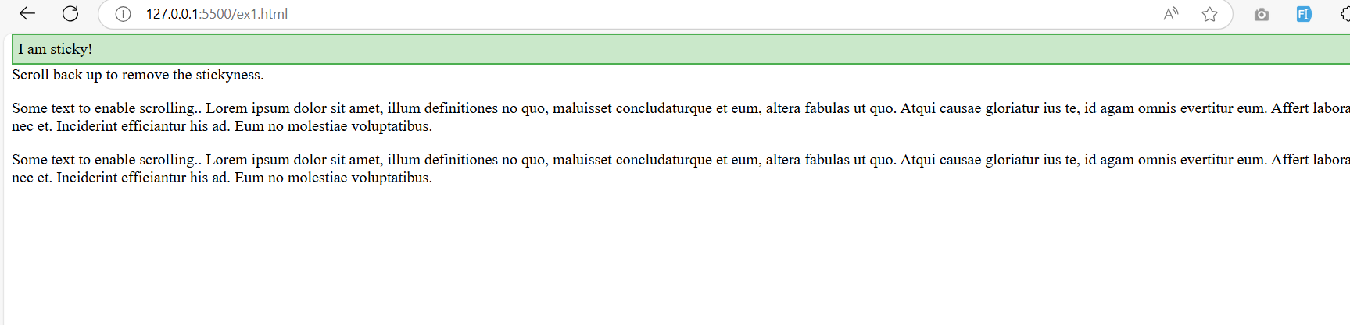

<!DOCTYPE html>

<html>

<head>

<style>

.sticky {

  position: sticky;

  top: 0;

  padding: 5px;

  background-color: #cae8ca;

  border: 2px solid #4CAF50;

}

</style>

</head>

<body>

<p>Try to <b>scroll</b> inside this frame to understand how sticky positioning works.</p>

<div class="sticky">I am sticky!</div>

<div style="padding-bottom:2000px">

  <p>In this example, the sticky element sticks to the top of the page (top: 0), when you reach its scroll position.</p>

  <p>Scroll back up to remove the stickyness.</p>

  <p>Some text to enable scrolling.. Lorem ipsum dolor sit amet, illum definitiones no quo, maluisset concludaturque et eum, altera fabulas ut quo. Atqui causae gloriatur ius te, id agam omnis evertitur eum. Affert laboramus repudiandae nec et. Inciderint efficiantur his ad. Eum no molestiae voluptatibus.</p>

  <p>Some text to enable scrolling.. Lorem ipsum dolor sit amet, illum definitiones no quo, maluisset concludaturque et eum, altera fabulas ut quo. Atqui causae gloriatur ius te, id agam omnis evertitur eum. Affert laboramus repudiandae nec et. Inciderint efficiantur his ad. Eum no molestiae voluptatibus.</p>

</div>

</body>

</html>

**9.List**

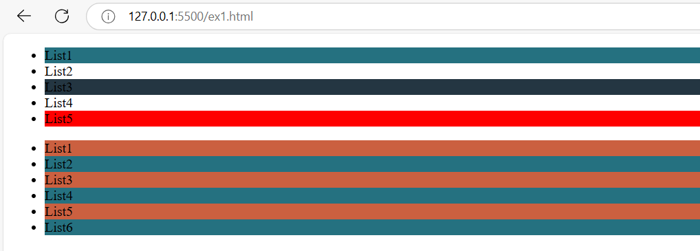

<!DOCTYPE html>

<head>

    <title>Document</title>

    <style>

        .list1 li:first-child{

            background-color:#257180;

        }

        .list1 li:last-child{

            background-color: red;

        }

        .list1 li:nth-child(3){

            background-color:#243642;

        }

        .list2 li:nth-child(odd){

            background-color:#CB6040;

        }

        .list2 li:nth-child(even){

            background-color:#257180;

        }

    </style>

</head>

<body>

    <ul class="list1">

        <li>List1</li>

        <li>List2</li>

        <li>List3</li>

        <li>List4</li>

        <li>List5</li>

    </ul>

    <ul class="list2">

        <li>List1</li>

        <li>List2</li>

        <li>List3</li>

        <li>List4</li>

        <li>List5</li>

        <li>List6</li>

    </ul>

</body>

</html>

**10.HOVER**

<!DOCTYPE html>

<html lang="en">

<head>

    <meta charset="UTF-8">

    <meta name="viewport" content="width=device-width, initial-scale=1.0">

    <title>Document</title>

    <style>

      .button{

        background-color:#3B1E54;

        color:#EEEEEE;

        padding: 20px;

      }

      .button:hover{

        background-color: #C62E2E;

        color:#0D92F4;

        padding: 20px;

      }

    </style>

</head>

<body>

    <button class="button">Click Me</button>

</body>

</html>

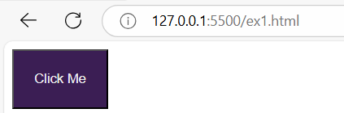

**CSS LINK:**

https://tympanus.net/codrops/css_reference/